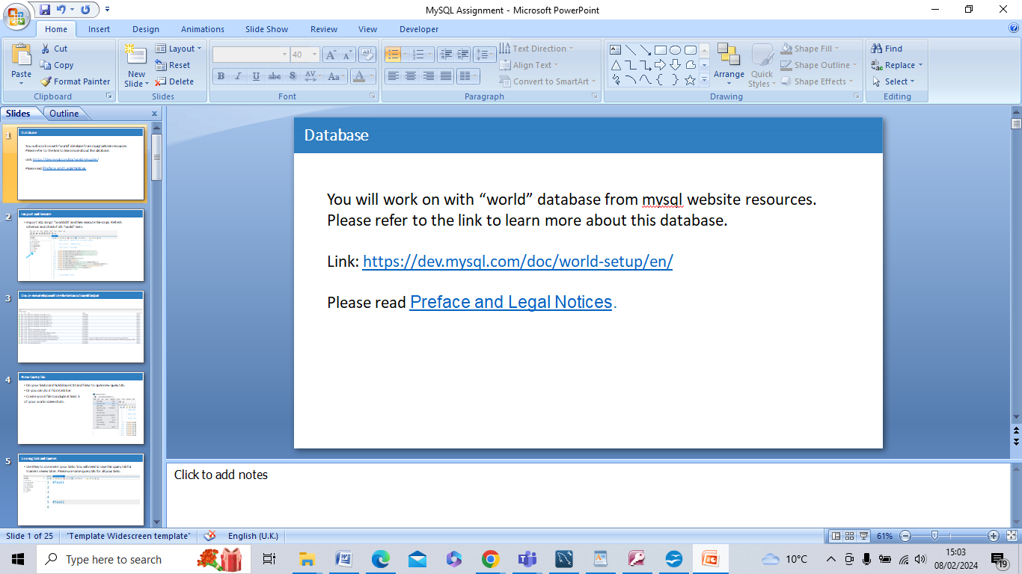

Overall, the Preface provides legal and usage guidelines for users of the “world db” sample database, including copyright information, licensing restrictions, warrantee disclaimers, and guidelines for using the database.

Top of Form

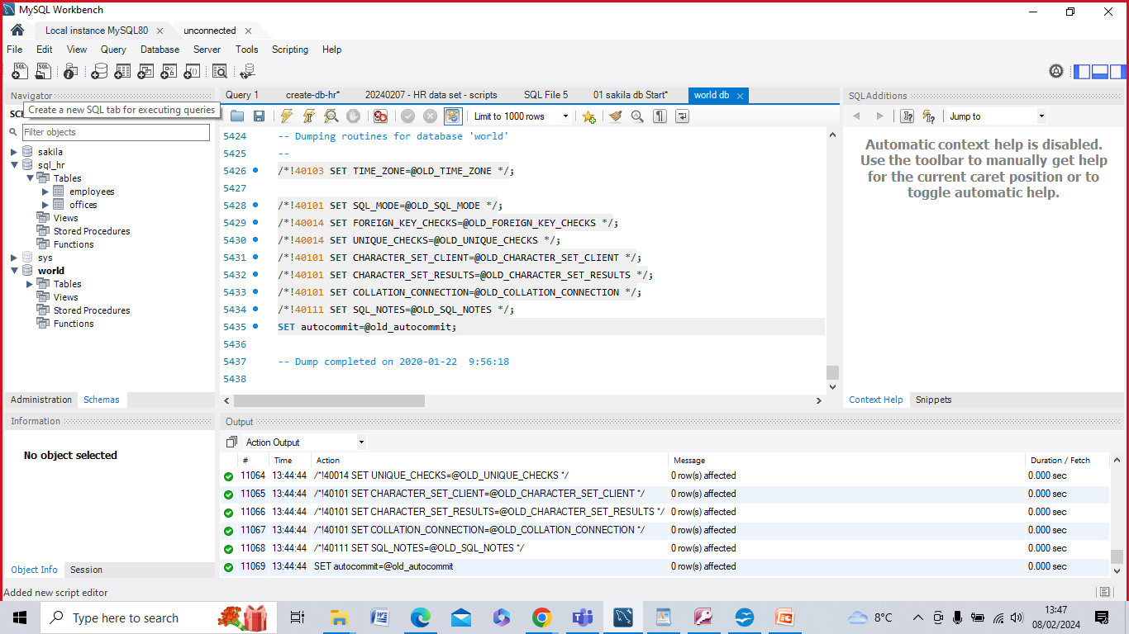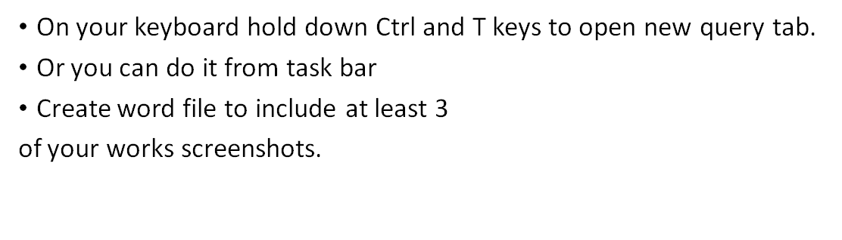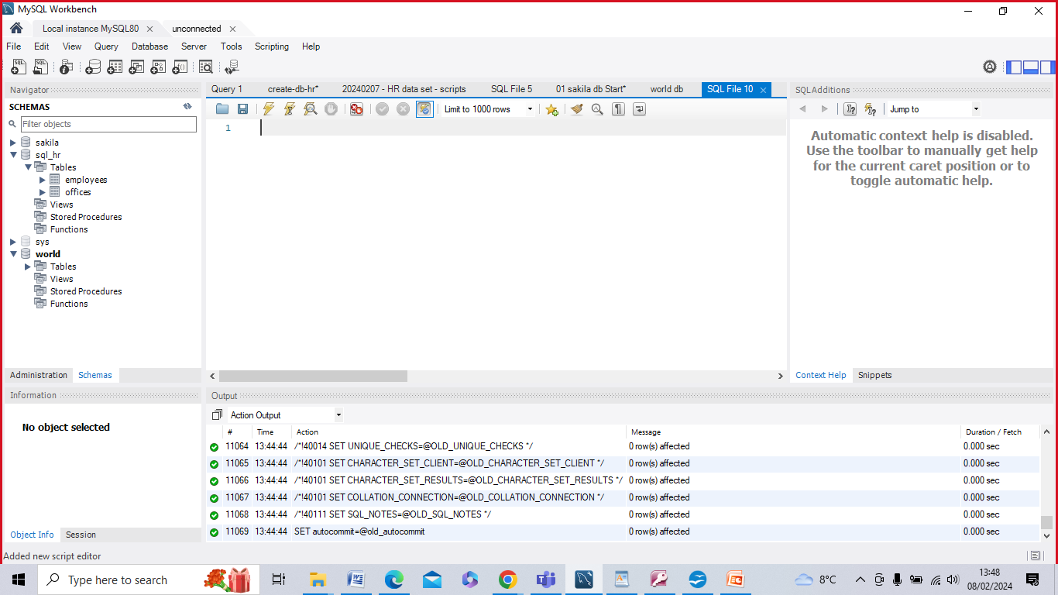



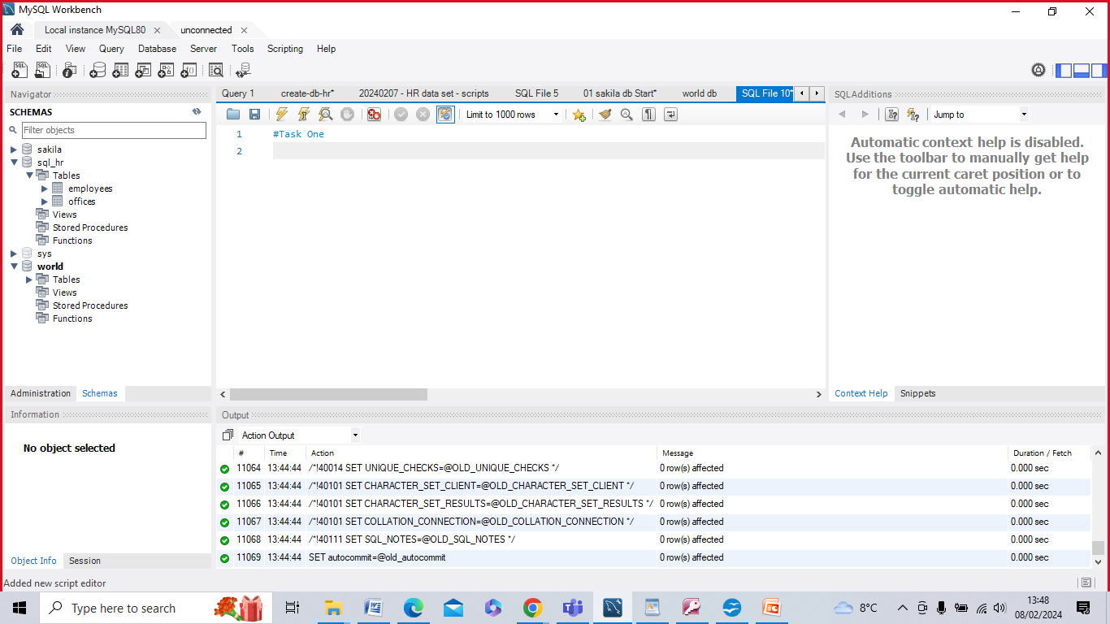

|  |
| --- |
| This project concerns a new Schema called 'World db'. |
| World db contains the following tables: |
| * 'city', |
| * 'country', |
| * 'countrylanguage' |
|  |
| 'City' table contains the following Columns: |
| * 'ID', |
| * 'Name', |
| * 'CountryCode', |
| * 'District', |
| * 'Population' |
|  |
| 'Country' table contains the following Columns: |
| * 'Code', |
| * 'Name', |
| * 'Continent', |
| * 'Region', |
| * 'SurfaceArea', |
| * 'IndepYear', |
| * 'Population', |
| * 'LifeExpectancy', |
| * 'GNP', |
| * 'GNPOld', |
| * 'LocalName', |
| * 'GovernmentForm', |
| * 'HeadOfState', |
| * 'Capital', |
| * 'Code2' |
|  |
| 'CountryLanguage' table contains the following Columns: |
| * 'CountryCode', |
| * 'Language', |
| * 'IsOfficial', |
| * 'Percentage’ |

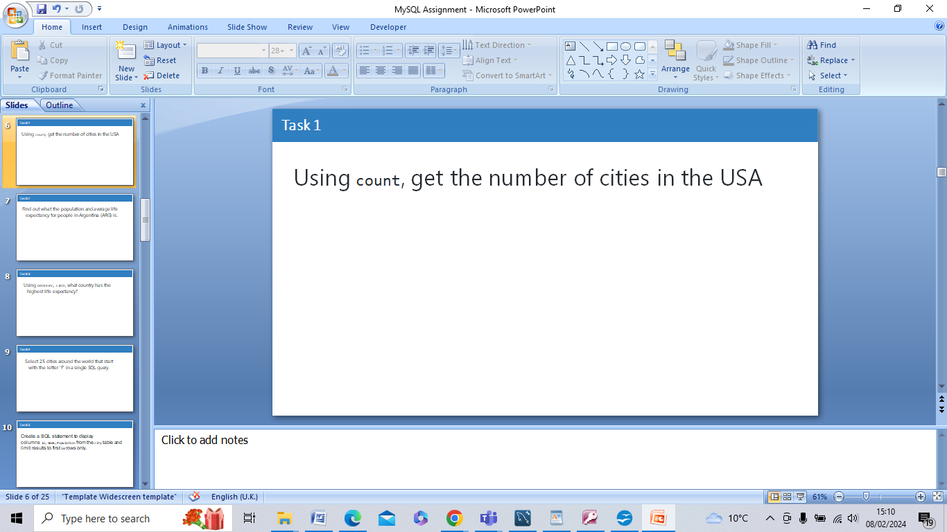

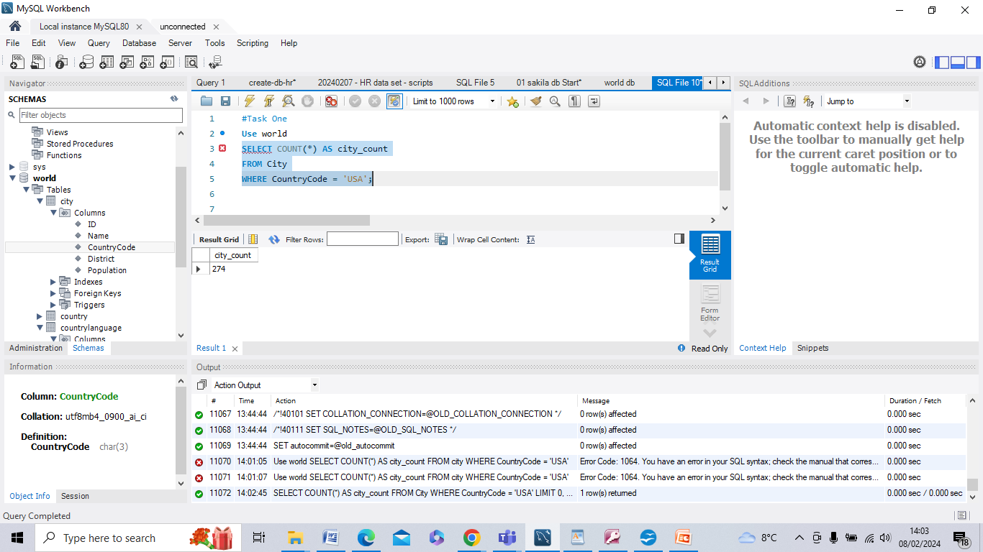

The Query selects the count of rows (in cities) from the 'city' table selecting the 'CountryCode' column where this is 'USA', indicating that the cities are in the United States. This results in a figure for the number of cities in the USA, which is ‘274’.

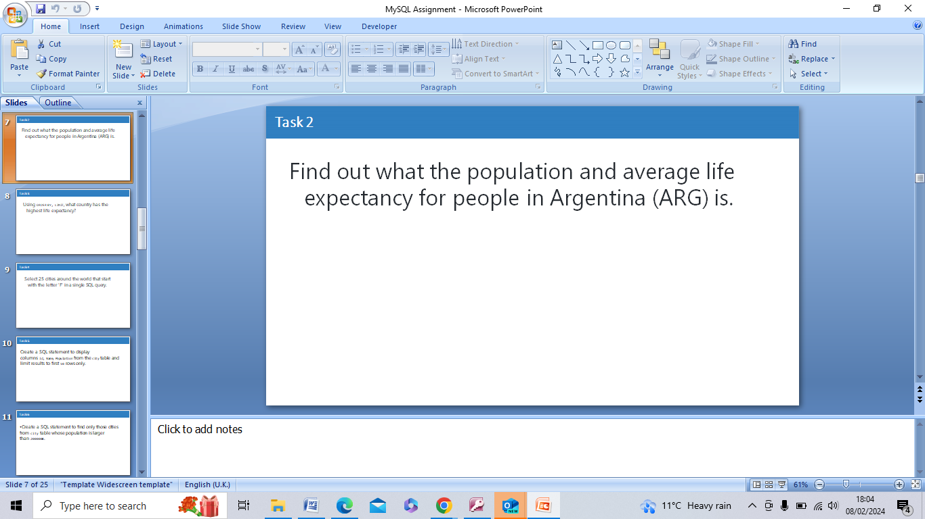

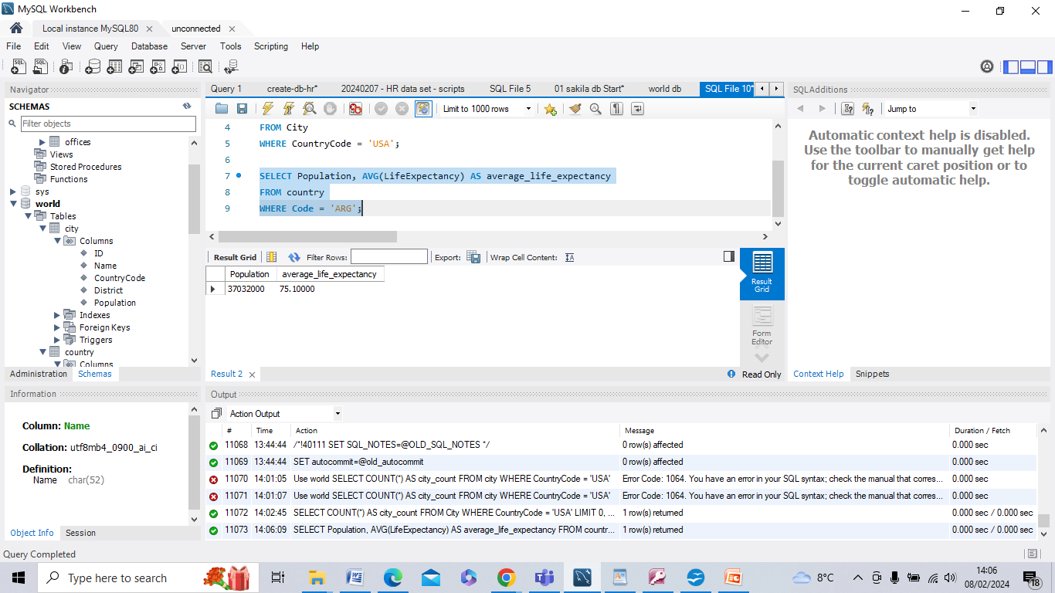

'Population' is selected and used to calculate the average of 'LifeExpectancy' for Argentina from the 'country' table where the 'Code' column is 'ARG'. The result gives total population and average life expectancy for people in Argentina under two created headings:

ARG

Population: 37,032,000

Average_Life_Expectancy: 75.1 years

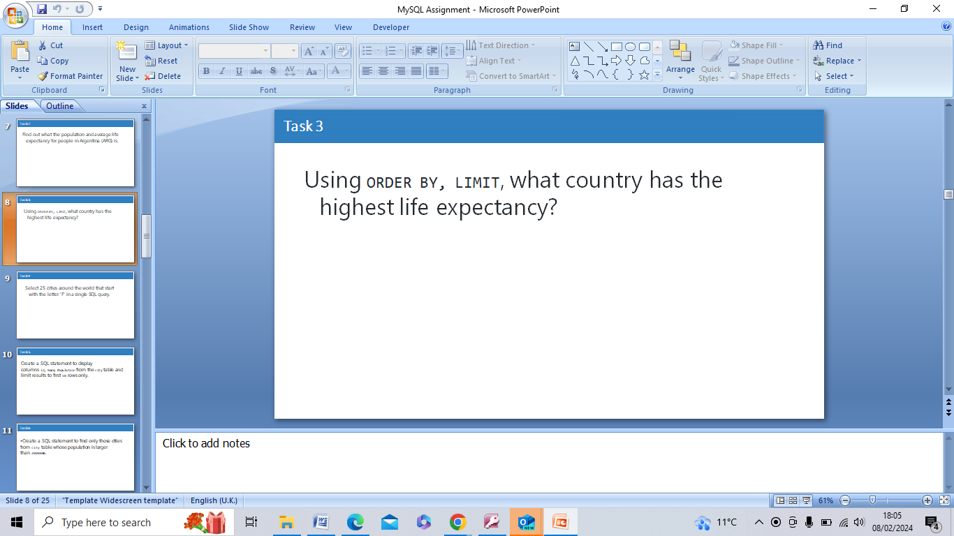

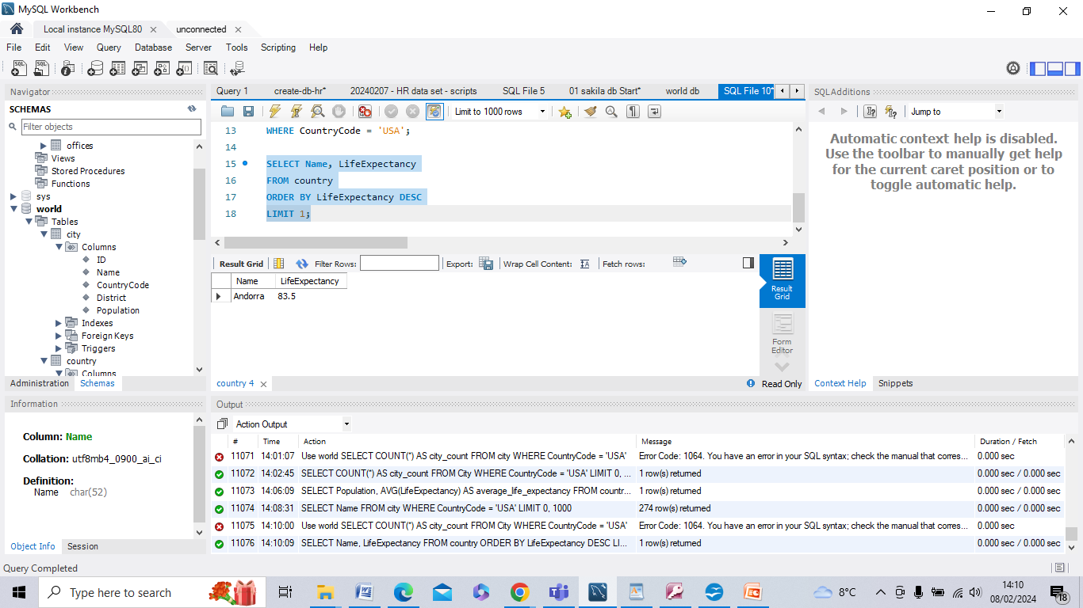

The Query selects 'Name' (country name) and 'LifeExpectancy' columns from the 'country' table and orders the results by 'LifeExpectancy' in descending order using the ORDER BY clause. The LIMIT 1 clause ensures that only the first row (country with the highest life expectancy) is returned.

Andorra – 83.5 years average life expectancy

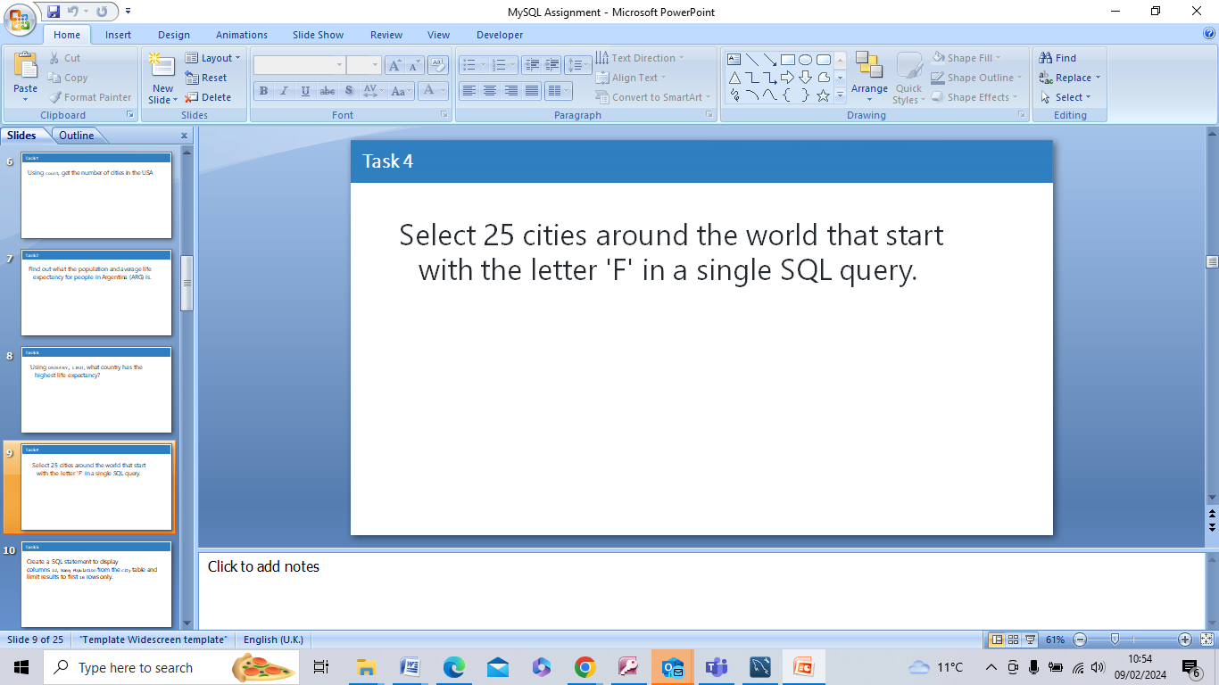

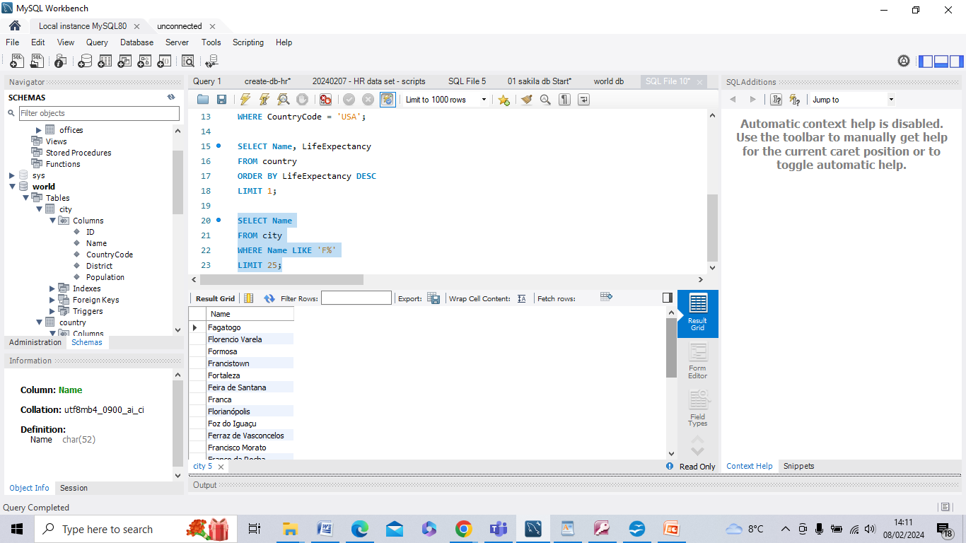

Tthe names of cities from the 'city' table are selected where the 'Name' column starts with the letter 'F'. This is done using the LIKE operator with the wildcard pattern 'F%', which matches any string that starts with 'F'. The LIMIT 25 clause ensures that only 25 rows are returned.

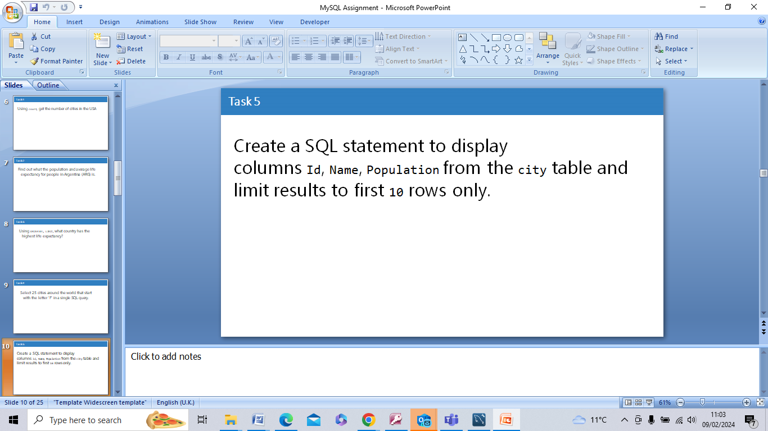

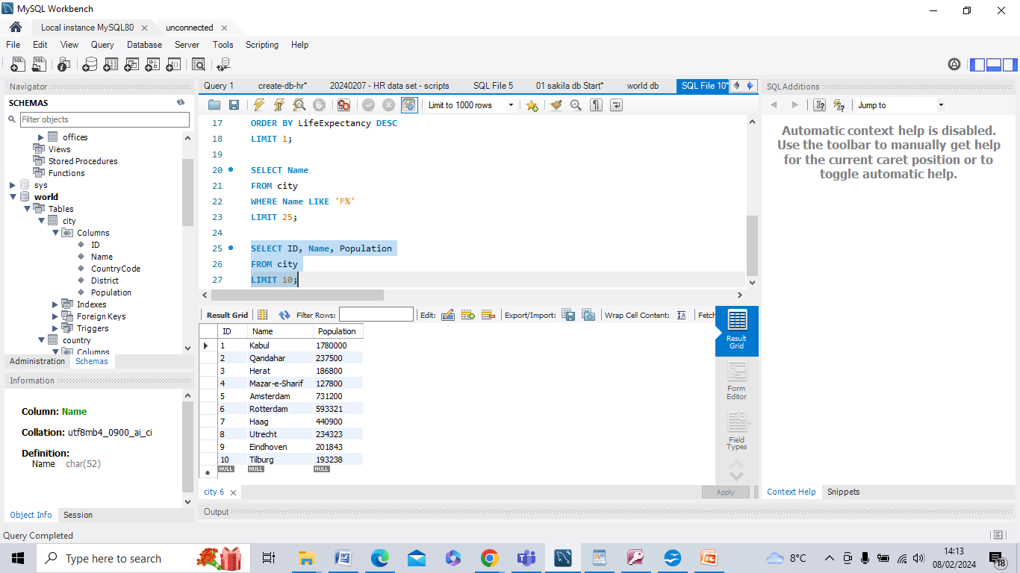

The specified columns from the 'city' table are selected; the LIMIT clause limits results to the first 10 rows.

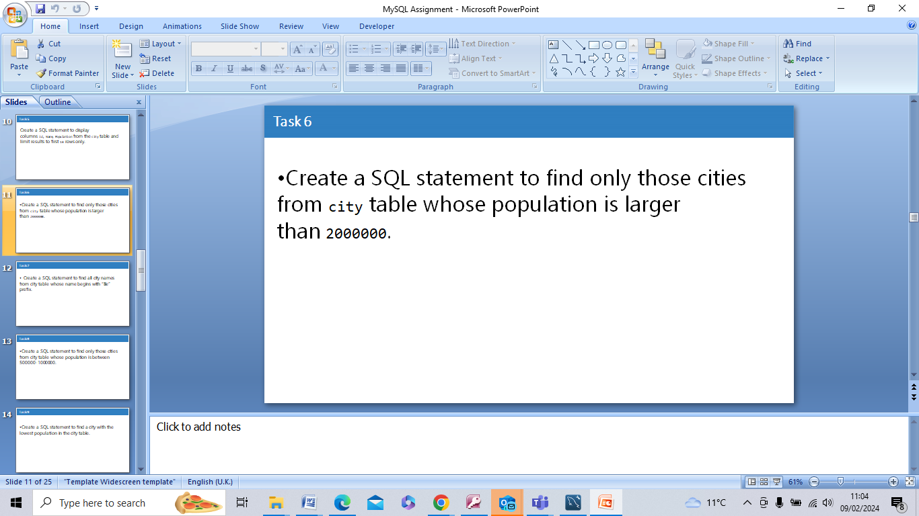

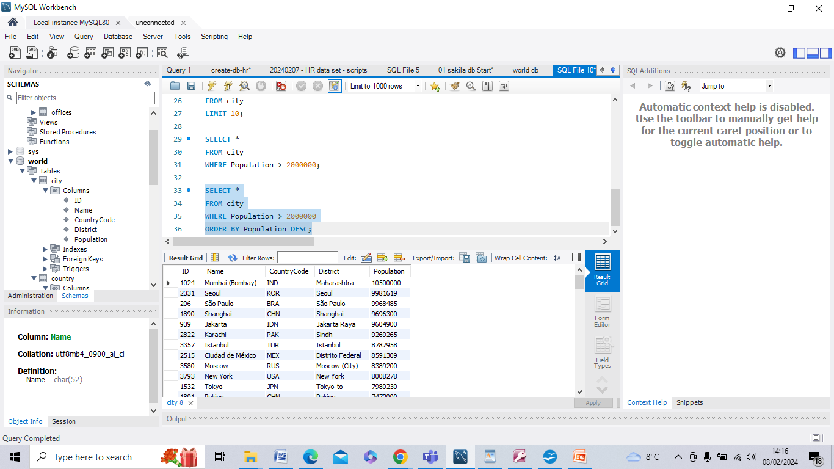

This query selects all columns from the 'city' table where the 'Population' column is larger than 2,000,000. It only returned the rows (cities) that met the condition.

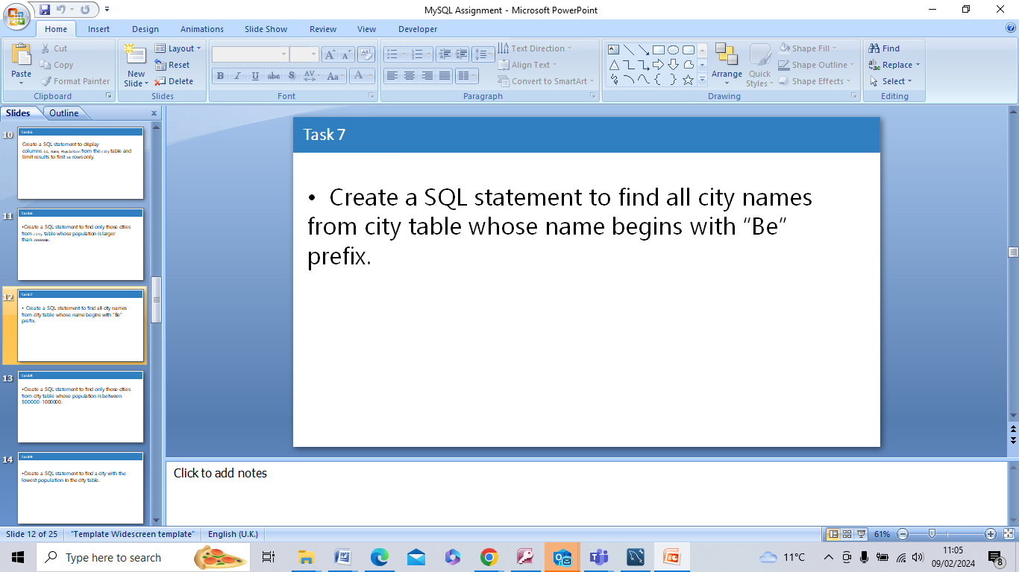

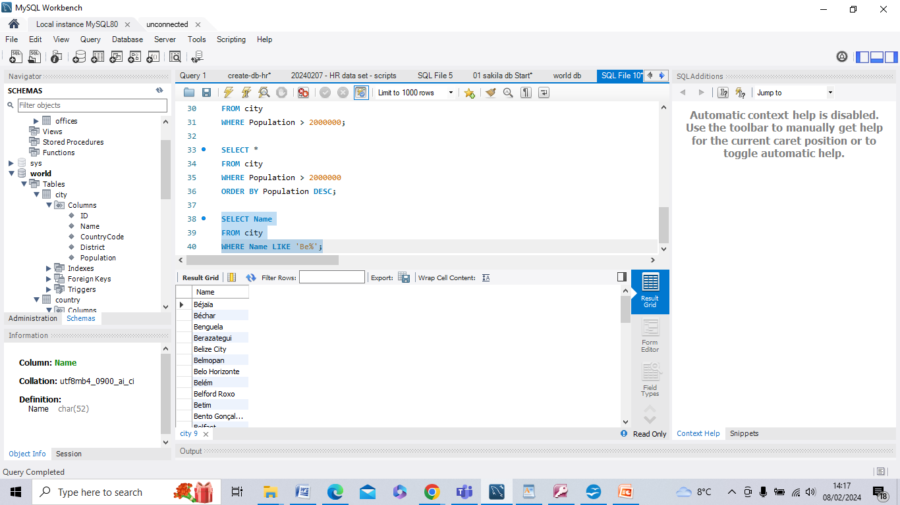

The 'Name' column is selected from the 'city' table, but only where the 'Name' column starts with the prefix "Be". This is done using the LIKE operator with the pattern 'Be%' (wildcard). It returns all city names that match this pattern.

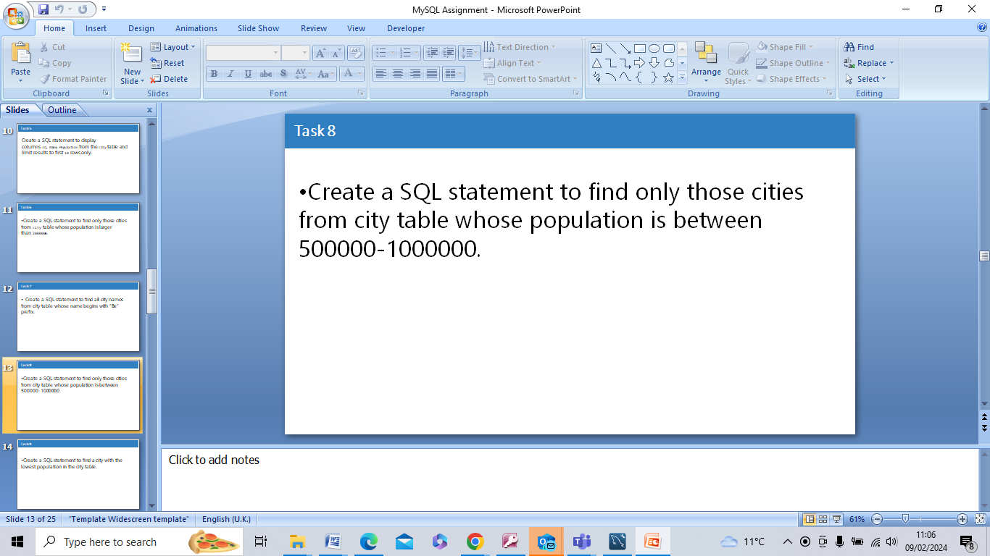

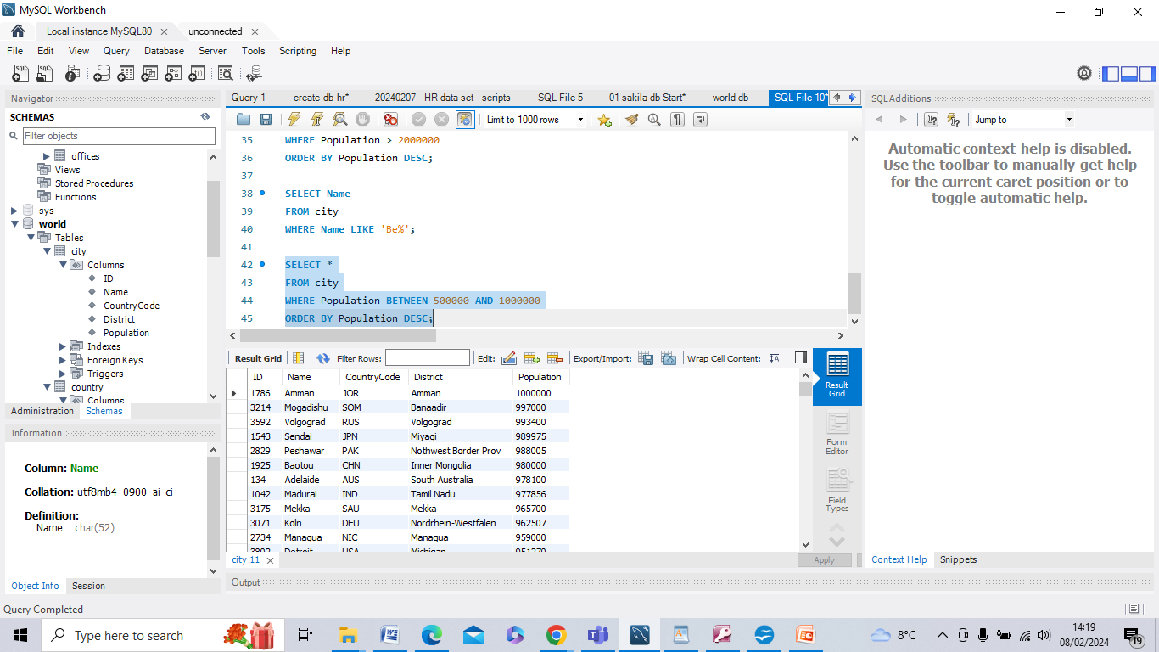

This query selects all columns from the 'city' table where the 'Population' column is between 500,000 and 1,000,000 inclusive. This is done using the BETWEEN operator. It returns only the rows (cities) that meet the criteria.

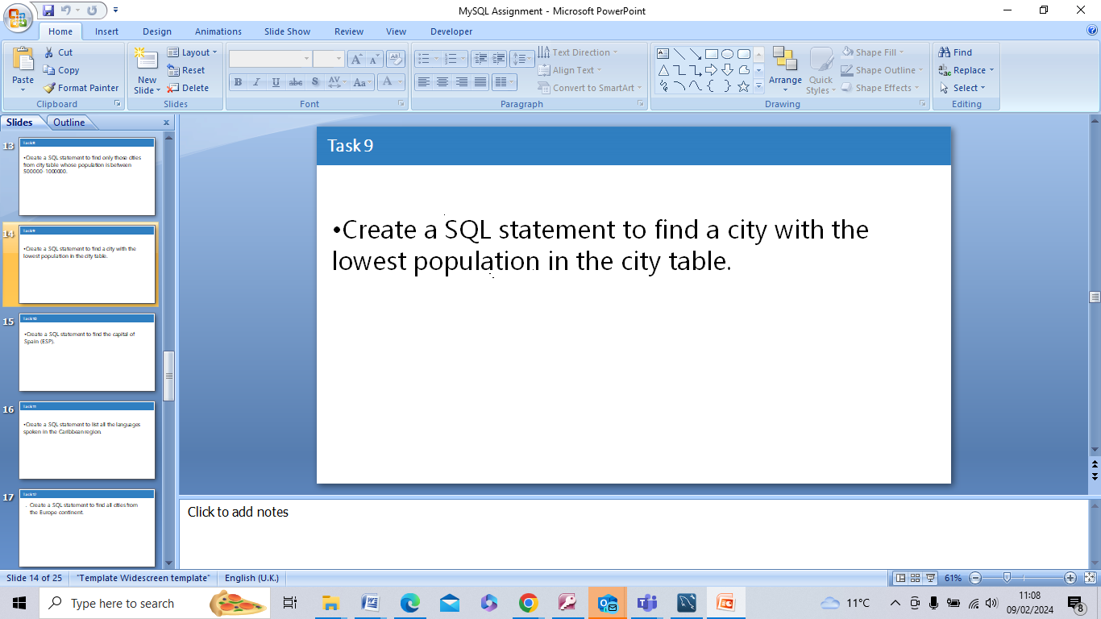

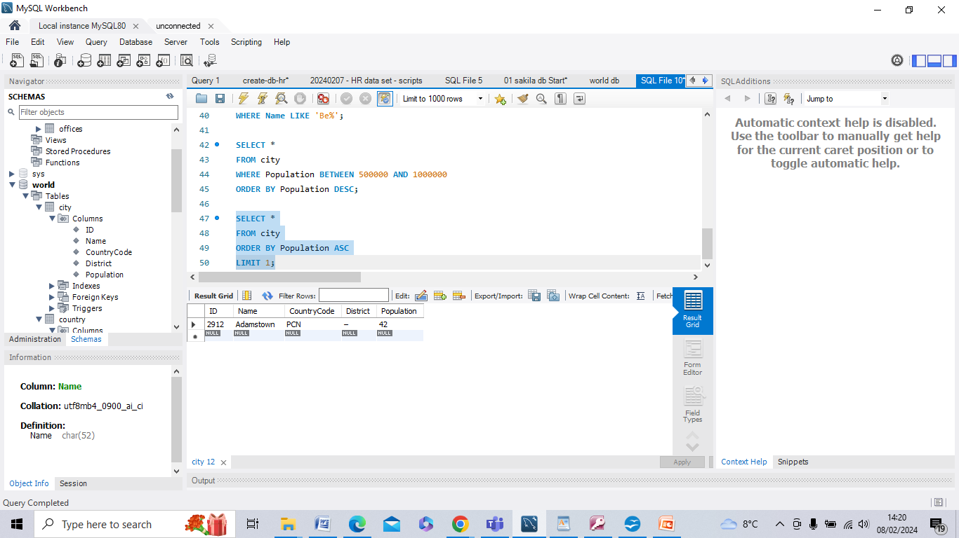

This selects all columns from the 'city' table and orders the result by population, but in ascending order (from lowest to highest). The LIMIT 1 clause then ensures that only the first row (city with the lowest population) is returned.

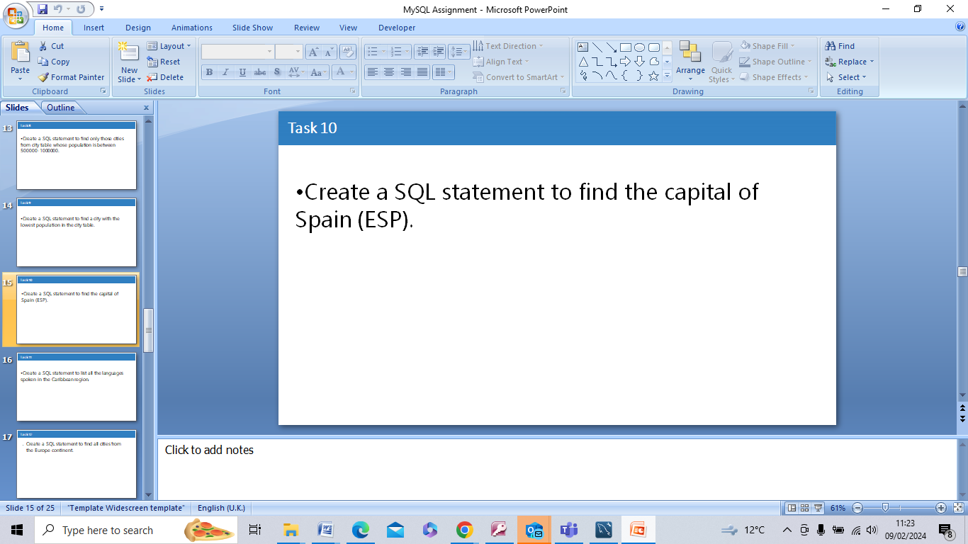

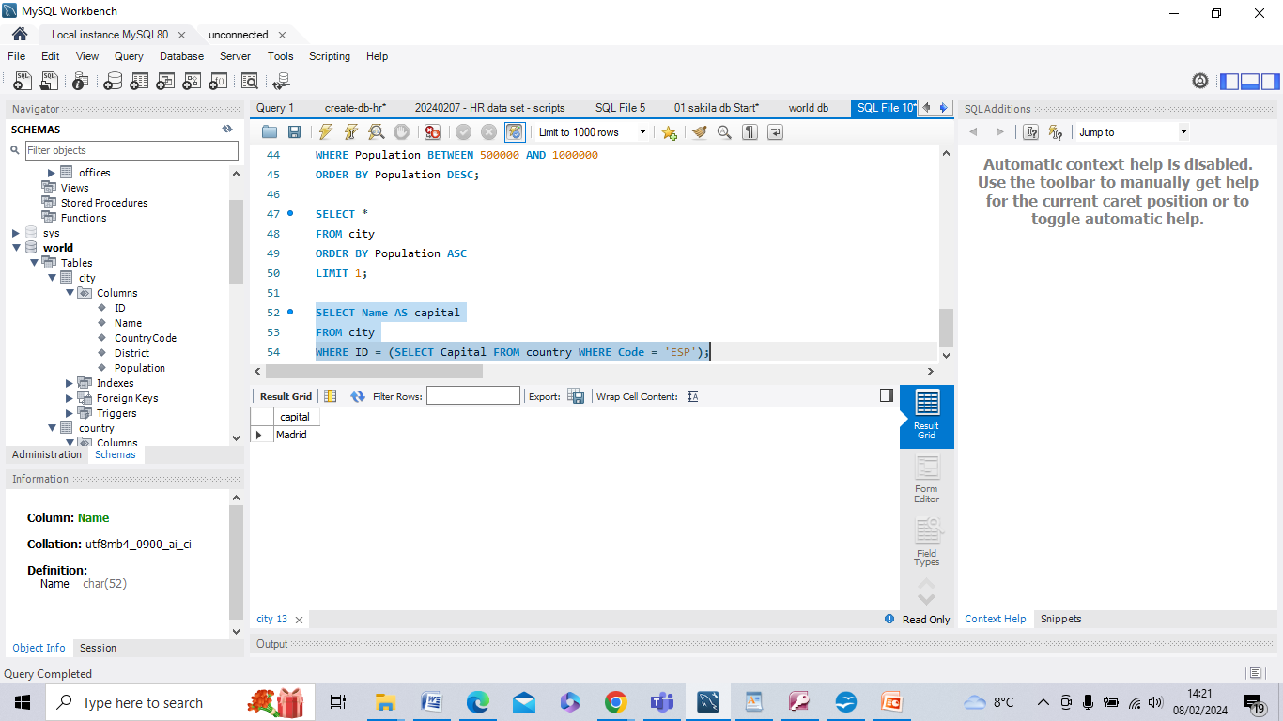

The 'Name' column from the 'city' table is selected and is used to retrieve the capital city's name by matching the 'Capital' column value (which represents the city ID of the capital) from the 'country' table, but only where the country code is 'ESP' (Spain).

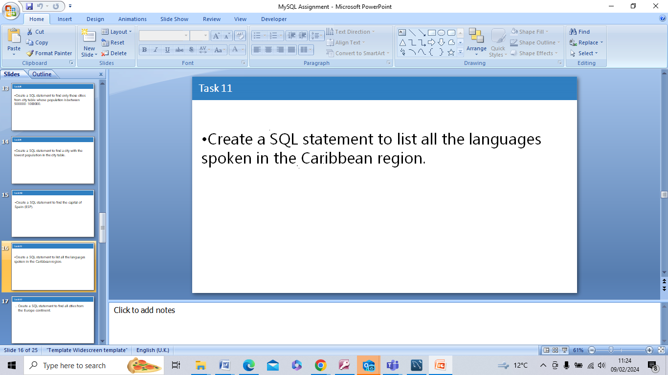

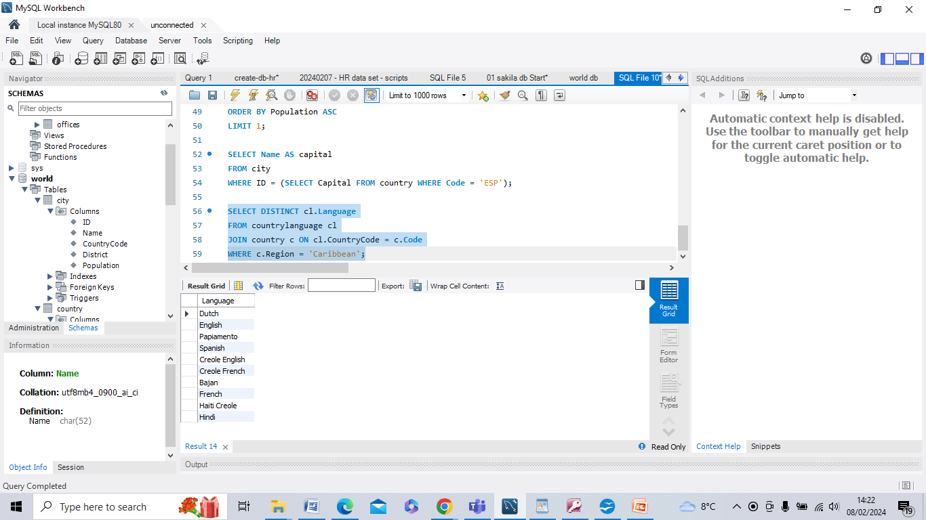

The task is to select the distinct languages from the 'countrylanguage' table and retrieve the languages spoken in the Caribbean region, this is done by joining with the 'country' table on the 'CountryCode' column and filtering rows where the region is 'Caribbean'.

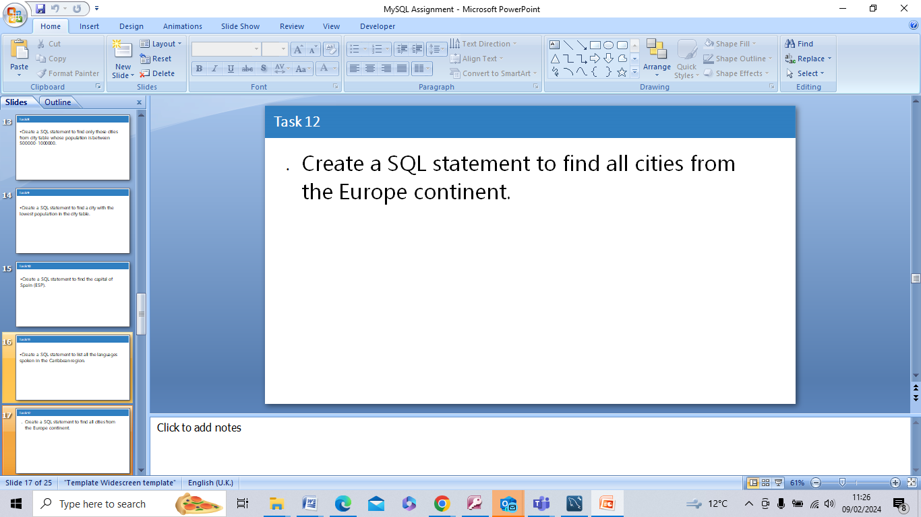

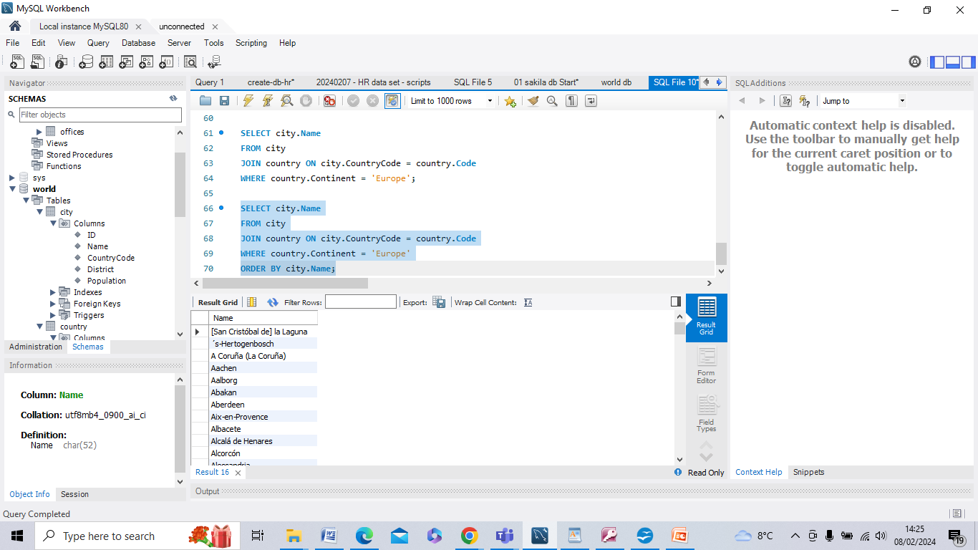

This query selects the city names from the 'city' table by joining it with the 'country' table on the 'CountryCode' column. It then filters the rows where the continent is 'Europe' from the 'country' table.



**1. Primary key in country table:**

* In the 'country' table of the 'world' database, **the primary key is the 'Code' column**. This column uniquely identifies each country in the table.

**2. Primary key in city table:**

* In the 'city' table of the 'world' database, **the primary key is the 'ID' column**. This column uniquely identifies each city in the table.

**3. Primary key in countrylanguage table:**

* In the 'countrylanguage' table of the 'world' database, **the primary key is composed of the combination of the 'CountryCode' and 'Language' columns**. Together, these columns uniquely identify each language associated with a country in the table.

**4. Foreign key in city table:**

* In the 'city' table of the 'world' database, **the 'CountryCode' column serves as a foreign key**. It references the 'Code' column in the 'country' table, establishing a relationship between cities and their respective countries.

**5. Foreign key in countrylanguage table:**

* In the 'countrylanguage' table of the 'world' database, **the 'CountryCode' column serves as a foreign key**. Similar to the 'city' table, it references the 'Code' column in the 'country' table, establishing a relationship between languages and their respective countries.

**An easy way to find this using the EER Diagram is to click on the drop down ‘Indexes’ which then illuminates the Primary and Foreign Keys active in the Diagram.**

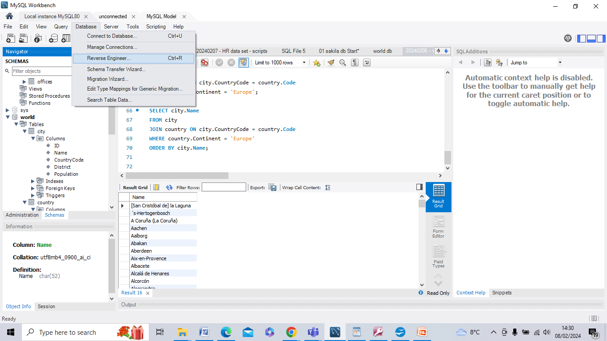

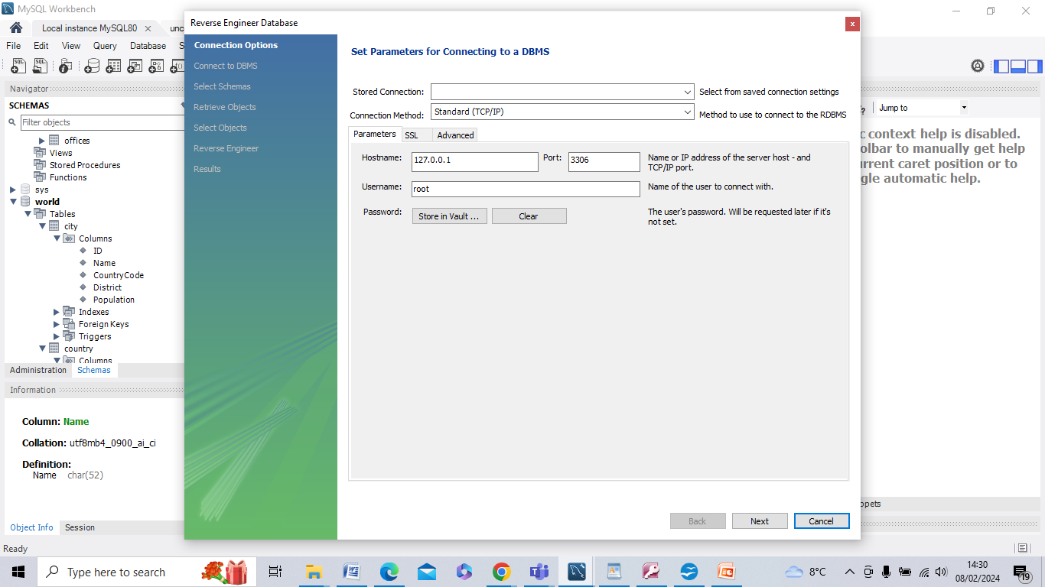

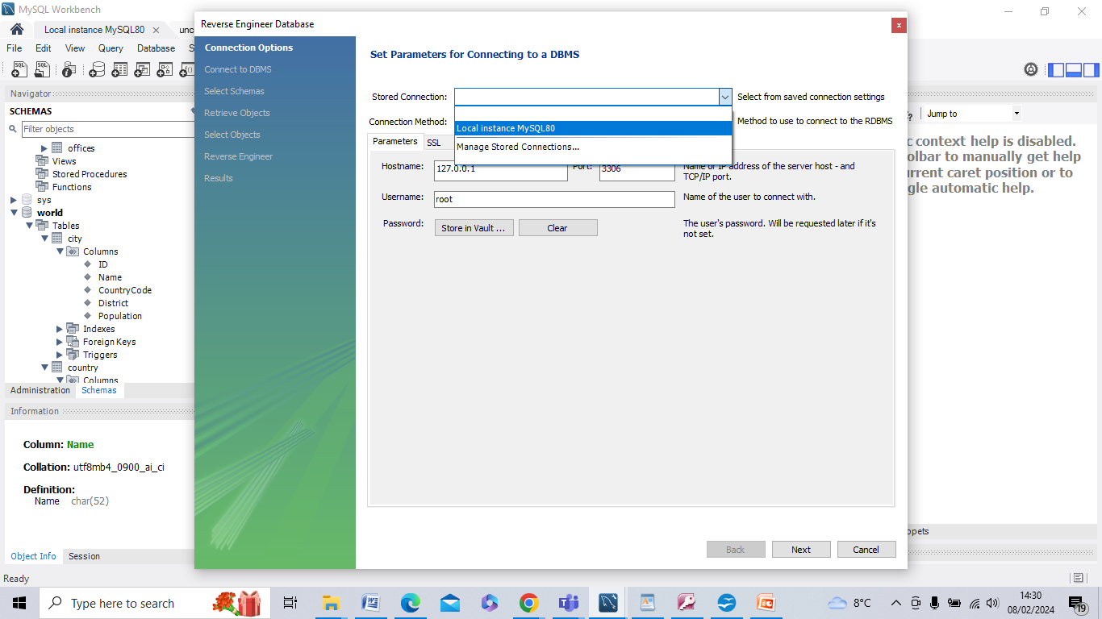

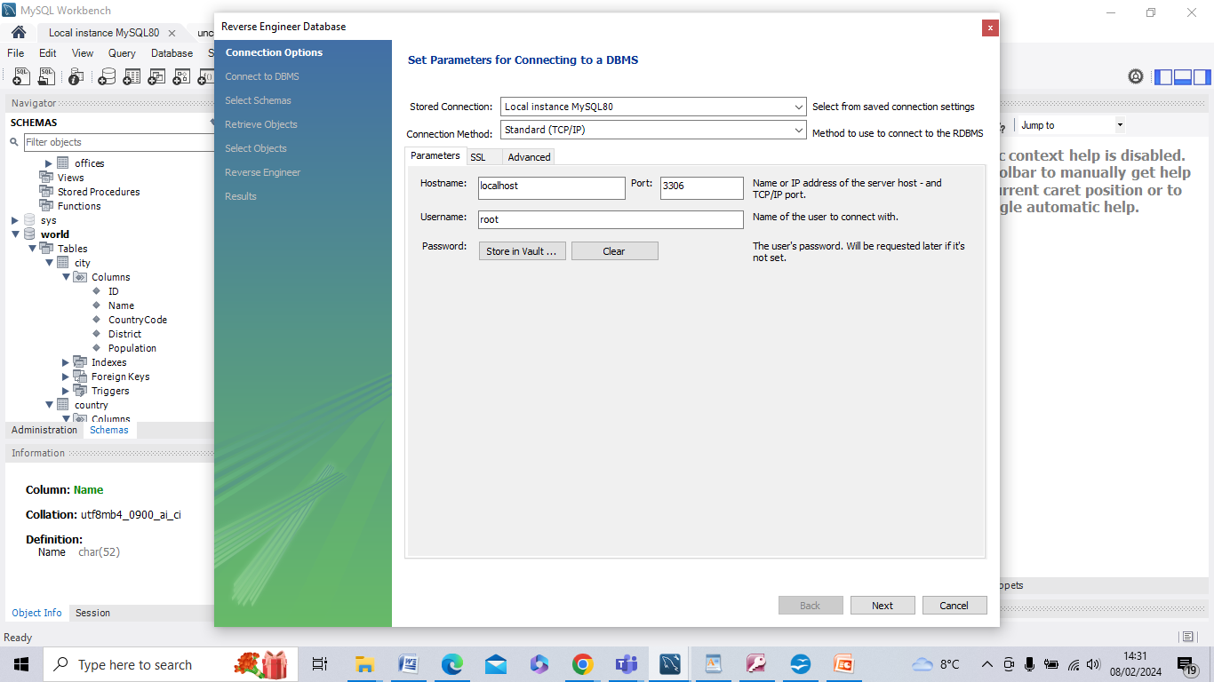

Press ‘Next’ which produces the following screen:

